**FUNCTIONAL SPECIFICATIONS**

**Venn Diagram Application**

**Group 12**

**04/15/2020**

**Version 3.0.0**

**1 INTRODUCTION** 3

1.1 Purpose 3

1.2 Intended Audience 3

1.3 Intended Use 3

**2 REQUIREMENTS** 3

2.1 Users 3

2.2 Overview of Functional Requirements 3

2.3 Overview of Technical Requirements 4

**3 CASES** 4

3.1 Use Cases 4

3.2 Acceptance Test Cases 4

**4 VERSION HISTORY** 7

# INTRODUCTION

A Venn Diagram is “a diagram representing mathematical or logic sets pictorially as circles or closed curves within an enclosing rectangle (the universal set), common elements of the sets being represented by the areas of overlap among the circles” (Dictionary.com, n.d.).

## Purpose

## The purpose of this project is to provide users with an interactive Venn diagram that maximizes customizability to the user’s desire to view and see the relationship between sets of information/items.

## Intended Audience

Users of this product may vary from a pre-teen to an older adult.

## Intended Use

An application that can draw customizable Venn diagrams for Strings of information.

**2 REQUIREMENTS**

## 2.1 Users

Product is designed for primary users, but can also be used by secondary users.

*Primary Users*

* Ranging from teens to middle-aged adults

*Secondary Users*

* Pre-teens and the elderly

## 2.2 Overview of Functional Requirements

* User is able to type anywhere they click
* A text can be dragged to any location inside the boundaries of the diagram
* Properties of the diagram and text can be modified (size, colour, style, etc.)
* User can customize multiple text at once
* Text can be organized using component alignment
* System includes an undo and redo mechanism
* Text can easily be deleted

## 2.3 Overview of Technical Requirements

* Venn diagram should consist of 2 overlapping circles
* Design of Venn Diagram is customizable (Colour, Theme, etc.)

**3 CASES**

## 3.1 Use Cases

* If a user is creating a Venn diagram and wants to work on it at a later time, the user can save the diagram, and edit it whenever they desire
* The Venn diagram can be saved by the user as a .txt file, .img file, .jpg file, .pdf file, and many more
* An existing Venn diagram can be imported and edited by the user

## 3.2 Acceptance Test Cases

* If the user clicks the top title of the Venn diagram where it says ‘Insert Title’ and types ‘A v B’, and the user clicks the sub-title where it says ‘Insert Title’ at the top of the left circle and types ‘A’ and the user clicks the sub-title where it says ‘Insert Title’ at the top of the right circle and types ‘B’. Then if the user double clicks under the subtitle ‘A’, a text appears ‘Insert Text 1’, and the user replaces it with ‘A’. Then if the user double clicks again under the subtitle ‘A’, a text will appear ‘Insert Text 2’. Once the user replaces it with ‘B’, the user can drag it to the other circle. Then the user may decide to change the size of the Venn diagram by clicking the design tab, and select the ‘Select All’ option in order to change the size of both circles at the same time. Then the user can either drag the bar to 230 under the ‘Size’ section or type 230 above the bar. The user may want to change the colour of only one of the circles. Let’s say the user wants to change the colour of the right circle to custom colour. In the design tab the user will click the first drop down menu and click ‘Right Circle’. Then under the Colour section, the user will have to click the drop down menu, then click ‘Custom Color…’, then the user may change it to whichever colour they desire, however let’s say the user slides the right colour bar all the way to the bottom, and drags the circle all the way to the bottom right in the colour square. This selection can also be obtained by changing the ‘Hue’ to 360 degrees, ‘Saturation’ to 100% ‘Brightness’ to 0%, and ‘Opacity’ to 100%. The user may save the colour for future use, so it will appear under the default colours as a ‘Custom Color’ option. When the user clicks ‘Use’, the colour of the right circle should change. The user may realize that it is hard to see the text in the right circle and want to change it to a more visible colour. The user will have to select the text by clicking it, and under the ‘Home’ tab under ‘Text Colour’ the user can either select a default colour or a custom colour. Let’s say the user selects the top left default colour. The user may then want to change the size of both texts. The user can do this by clicking anywhere on the Venn diagram besides any text object, then click ‘Ctrl+A’ to select all text objects besides the titles. Then the user can change size of the text in the ‘Home’ tab and click the drop-down menu located in the ‘Size’ section and click a different size for example size ’16.0’. The resulting Venn diagram should look like this:

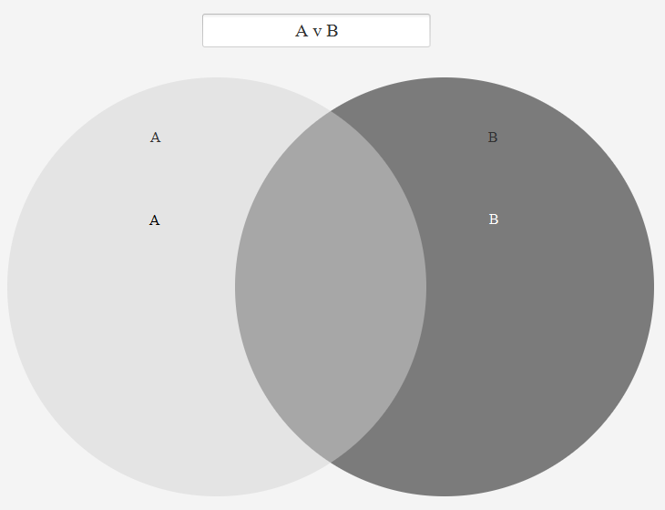

* If the user clicks the top title of the Venn diagram where it says ‘Insert Title’ and types ‘Soccer v Basketball’, and the user clicks the sub-title where it says ‘Insert Title’ at the top of the left circle and types ‘Soccer’ and the user clicks the sub-title where it says ‘Insert Title’ at the top of the right circle and types ‘Basketball’. Then if the user double clicks under the subtitle ‘Soccer’, a text appears ‘Insert Text 1’, and the user replaces it with ‘Ronaldo’. Then if the user double clicks again under the subtitle ‘Soccer’, a text will appear ‘Insert Text 2’. The user can replace it with ‘Messi’. Then if the user double clicks again under the subtitle ‘Soccer’, a text will appear ‘Insert Text 3’. The user can replace it with ‘Neymar’. Then if the user double clicks under the subtitle ‘Basketball’, a text appears ‘Insert Text 4’, and the user replaces it with ‘LeBron’. Then if the user double clicks again under the subtitle ‘Basketball’, a text will appear ‘Insert Text 5’. The user can replace it with ‘Kobe’. Then if the user double clicks again under the subtitle ‘Basketball’, a text will appear ‘Insert Text 6’. The user can replace it with ‘Curry’. Then the user may want to organize all the text to be aligned under each other. This can be done by clicking the ‘Design’ tab, and pressing ‘Select All’ under the first drop down menu, then clicking the drop-down menu under ‘Component Alignment’ select any of the 3 selections, but in this case the user will select ‘Right Justified’. Let’s say the user does not like the way the text looks on the left side of the Venn diagram. The user can select ‘Left Circle’ under the first drop down menu in the ‘Design’ tab, then select ‘Left Justified’ in the drop-down menu under the ‘Component Alignment’ section. Let’s say the user wants to change the colour of the Venn diagram as well. After selecting ‘Select All’ in the first drop down menu in the ‘Design’ tab, let’s say the user selects default colour (#6680e6), which is located in the 2nd column and 6th row in the ‘Colour’ drop-down menu. Then the user may want to change the font style and the font itself for all texts. To do this, the user will have to click anywhere on the Venn diagram, then click ‘Ctrl+A’ to select all text, then under the ‘Home’ tab click ‘Bell MT’ in the drop-down menu under the ‘Font’ section. Then the user can also click the box beside ‘**Bold**’ under the ‘Text Style’ section. Then the user may be interrupted by an emergency, the user can save the Venn diagram by clicking the ‘Save’ button under the ‘File’ tab. When the user returns, the user can click the ‘Load’ button located in the ‘File’ tab. The original diagram the user was working on should reappear. Say if the user accidentally double clicks the Venn diagram and a text appears, the user can click the ‘Undo’ button under the ‘File’ tab. And if the user wants to turn this setting off, so they can click the Venn diagram without text being added. This can be done by un-checking the box that says ‘Click to add text’ located at the bottom right. The user can also deselect ‘Auto focus on text’ and ‘Drag Text’ if the user does not want to make anymore changes. The resulting Venn diagram should look like this:

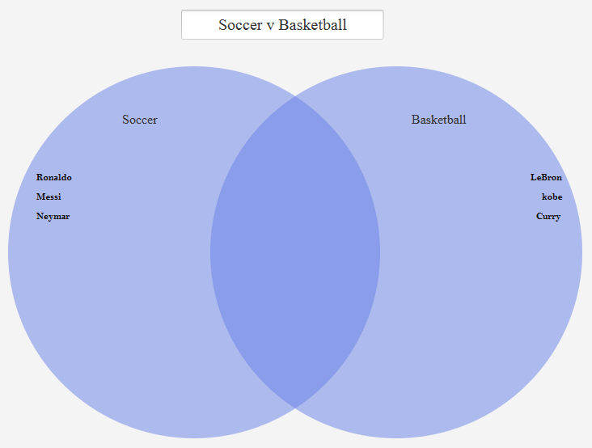

* If the user clicks outside the boundary of the Venn diagram, then the user should not be able to type anything

**4 VERSION HISTORY**

| VERSION | REVISION DATE | DESCRIPTION OF CHANGE | AUTHOR |
| --- | --- | --- | --- |
| 1.0.0 | Jan 26 2020 | 1st Version of Product | Group 12 |
| 1.1.0 | Feb 9 2020 | 1st Version of Prototype | Group 12 |
| 1.2.0 | Feb 23 2020 | 2nd Version of Prototype | Group 12 |
| 2.0.0 | Mar 8 2020 | Re-design and Functionality Upgrade | Group 12 |
| 2.0.1 | Mar 22 2020 | Bug Fixes | Group 12 |
| 3.0.0 | Apr 15 2020 | Final Version of Application | Group 12 |